Const Keyword :

const UserName=" Maitraiya "

console.log(UserName)

UserName="Karan"

console.log(UserName)

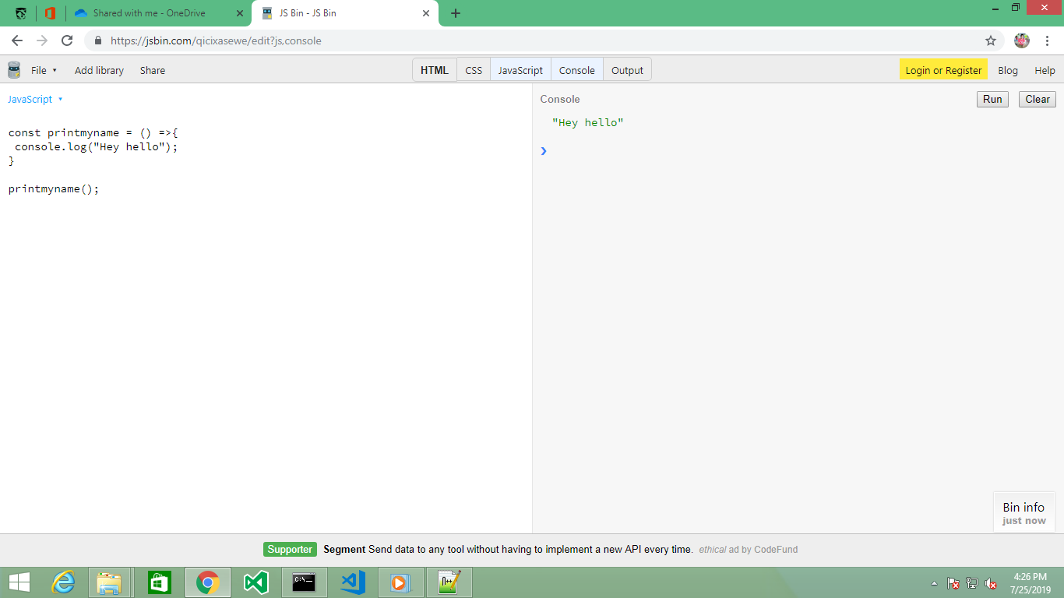

Arrow Function (1 Parameters)

const printmyname = () =>{

console.log("Hey hello");

}

printmyname();

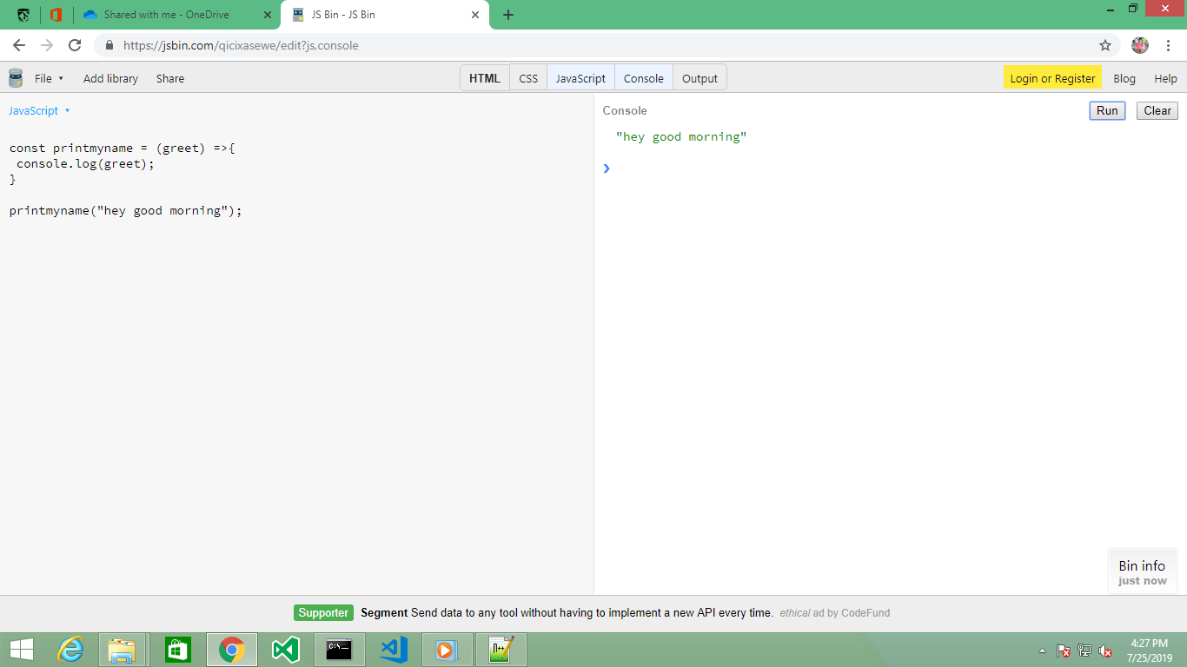

Arrow Function (With Parameters)

const printmyname = (num1,num2,num3) =>{

console.log("Average : "+(num1+num2+num3)/3);

}

printmyname(2,3,4);

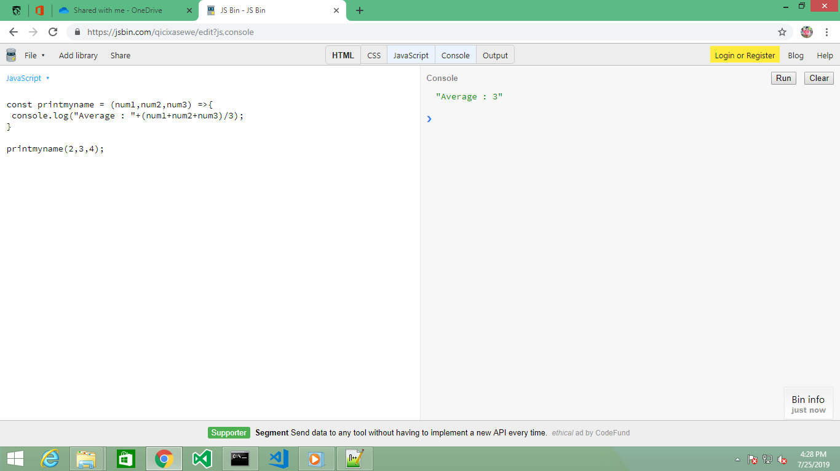

Arrow Function (With Parameters ,With return keyword)

const printmyname = (num1,num2,num3) =>{

return("Average : "+(num1+num2+num3)/3);

}

console.log(printmyname(2,3,4));

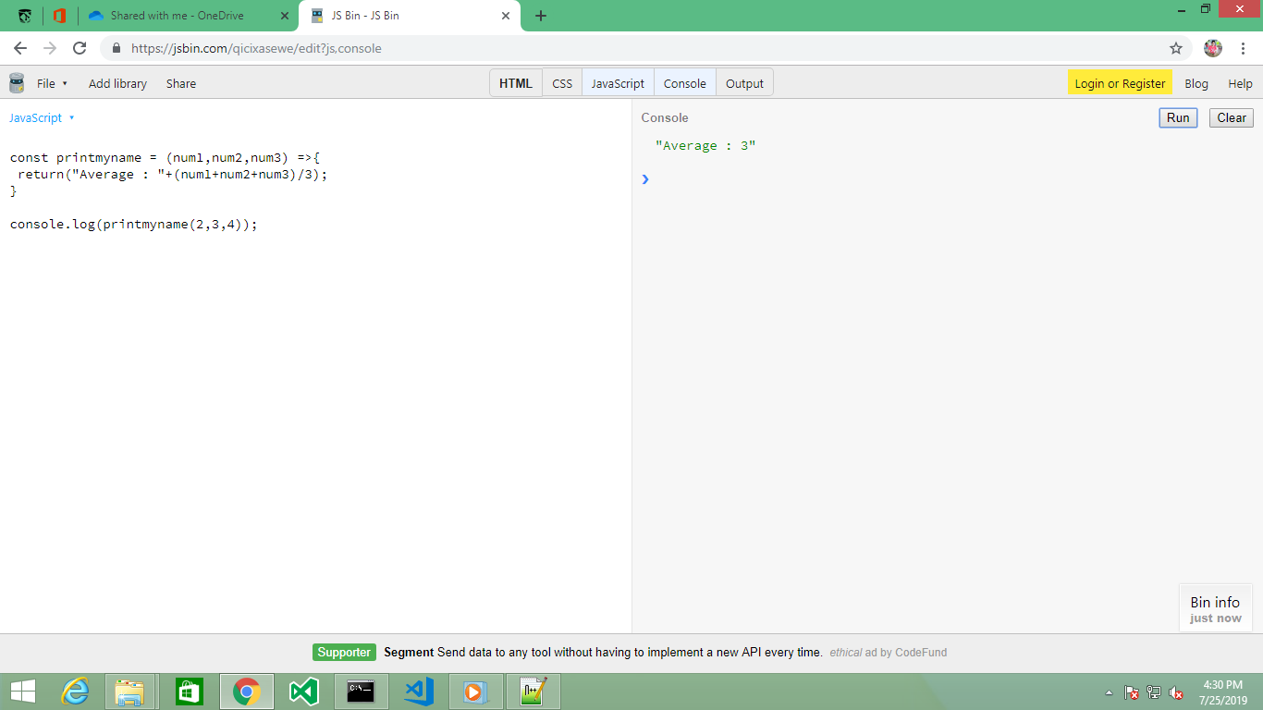

Arrow Function (With Parameters ,Without return keyword)

const printmyname = (num1,num2,num3) =>("Avg :"+(num1+num2+num3)/3);

console.log(printmyname(2,3,4));

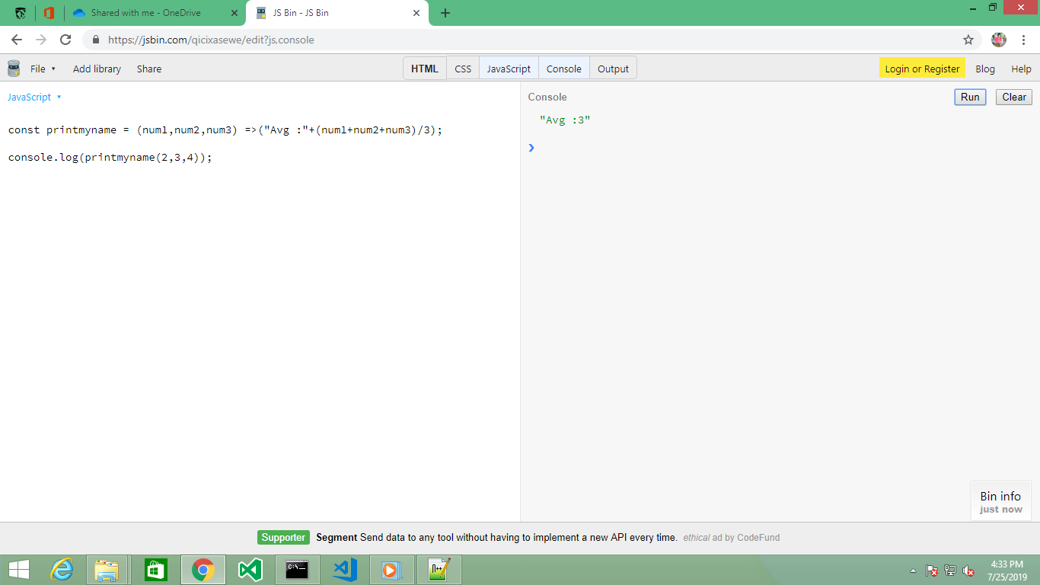

Usage of class

class Animals

{

constructor(){

this.gender="Male";

}

displaygender(){

console.log(this.gender);

}

}

const a= new Animals();

a.displaygender();

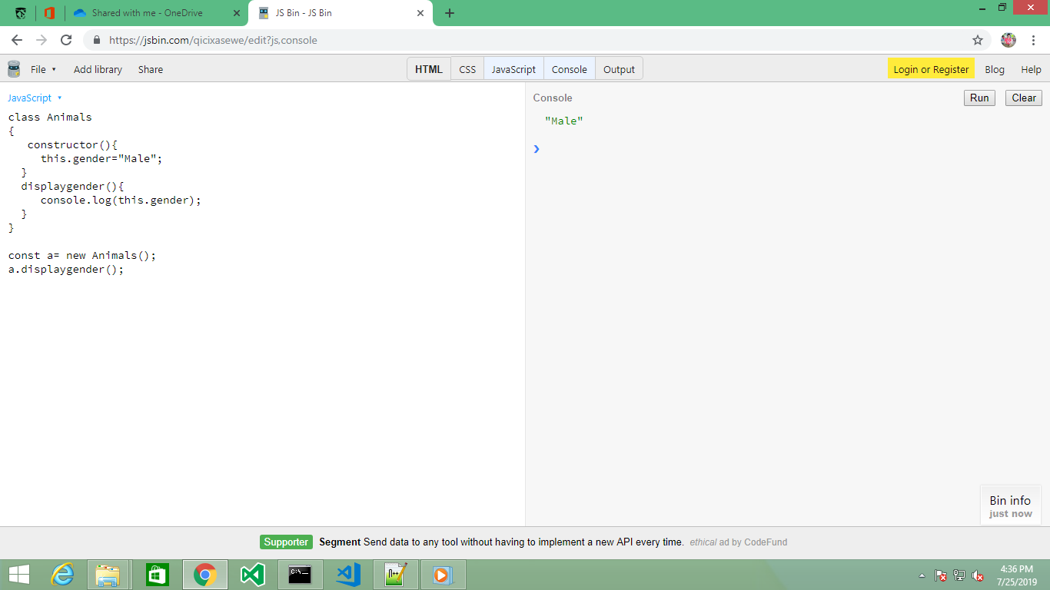

Usage of class (With Extends keyword)

class Animals

{

constructor(){

this.gender="Male";

}

displaygender(){

console.log(this.gender);

}

}

class Tiger extends Animals

{

constructor(){

super();

this.sound = "Roar";

}

displaysound(){

console.log(this.sound);

}

}

const t = new Tiger();

t.displaysound();

t.displaygender();

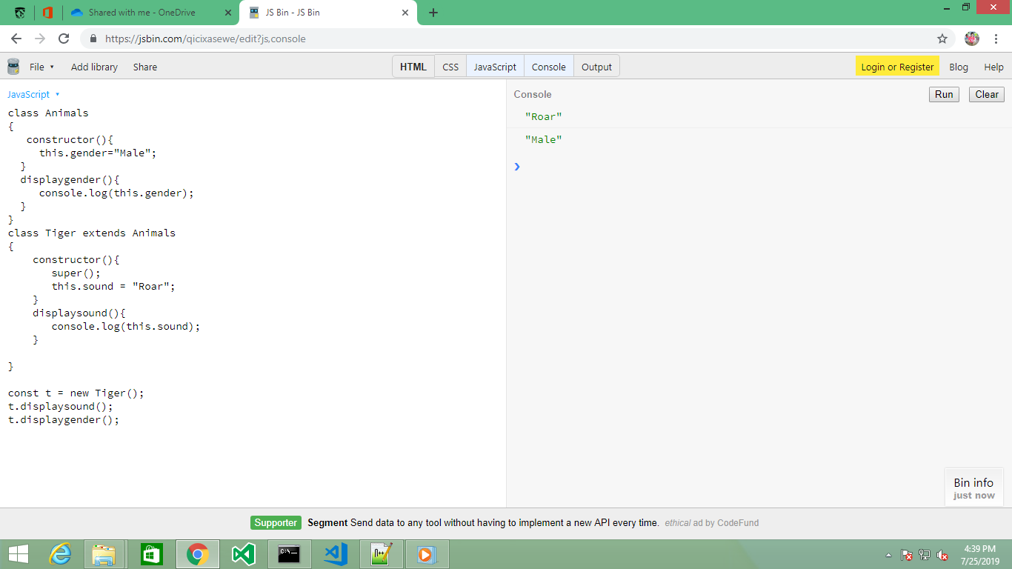

Usage of class (With Extends keyword,With Arrow Function)

class Animals

{

gender ="Male";

displaygender = () => {

console.log(this.gender);

}

}

class Tiger extends Animals

{

sound="Roar";

displaysound = () => {

console.log(this.sound);

}

}

const t = new Tiger();

t.displaysound();

t.displaygender();

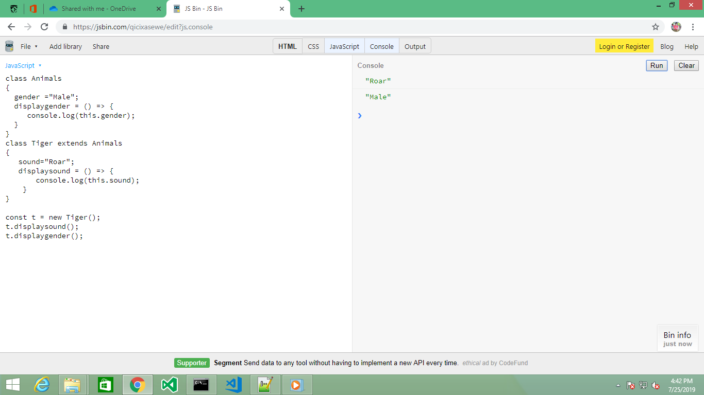

Usage of Spread(...)

const Animals = {

gender : 'male'

};

const Tiger ={

...Animals,

sound:'roar'

}

console.log(Tiger);

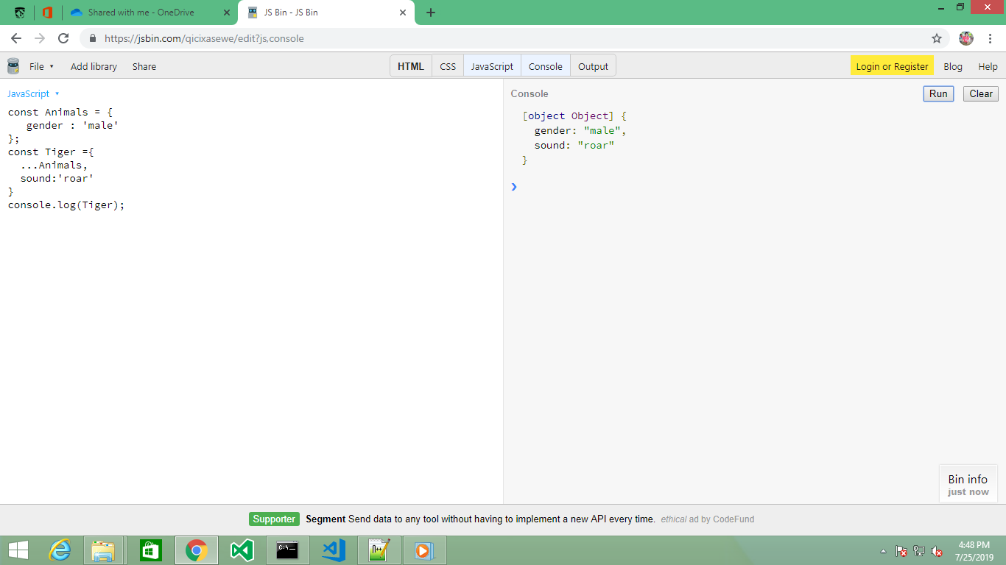

Usage of filter ()

const filter = (...args) => {

return args.filter(e => e===1)

}

console.log(filter(1,1,2,3));

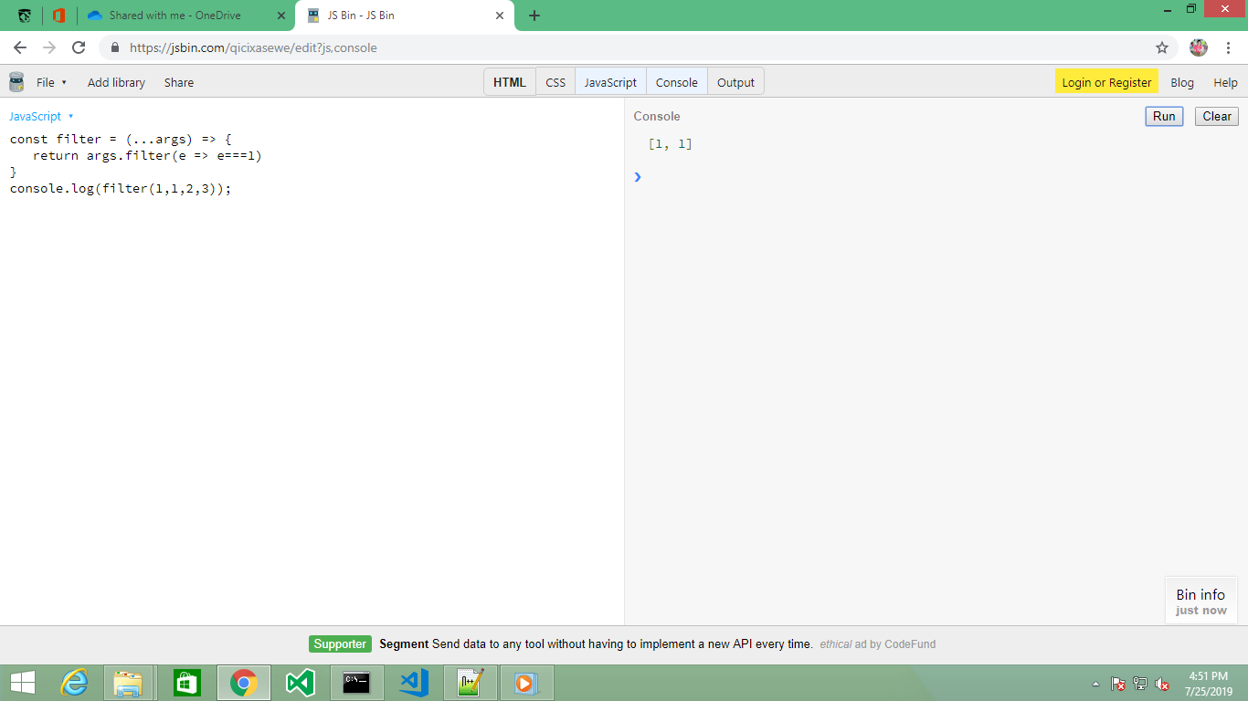

Usage of Destructuring

const nums =[1,2,3,4,5];

[num1, num2]=nums;

console.log(num1,num2);

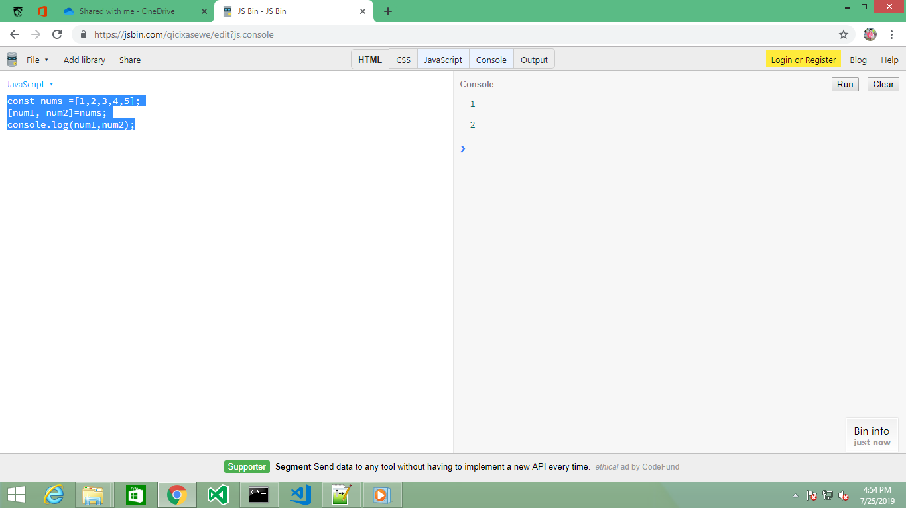

Refreshing References

const Tech = { name : 'IOT' }

console.log(Tech);

const Loving_Tech = Tech

Loving_Tech.name = 'AI / ML'

console.log(Loving_Tech)

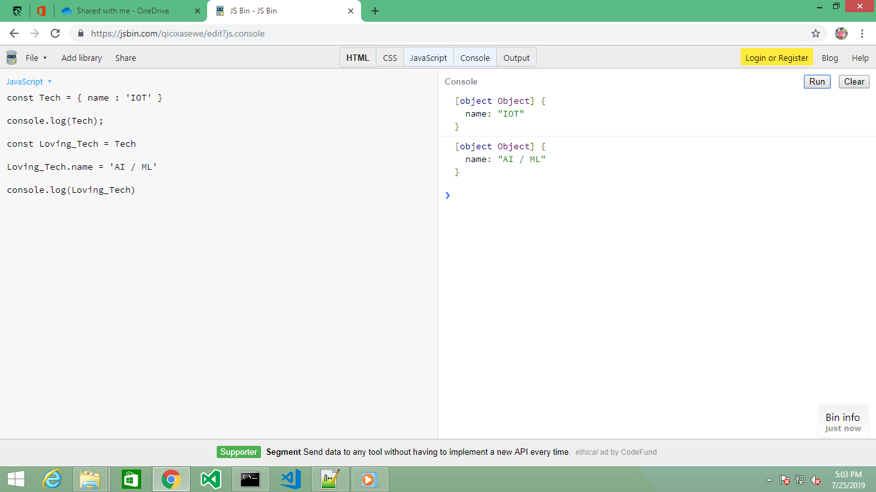

Refreshing References(Using spread ...)

const Tech = { name : 'IOT' }

console.log(Tech);

const Loving_Tech = {...Tech}

Loving_Tech.name = 'AI / ML'

console.log(Loving_Tech)

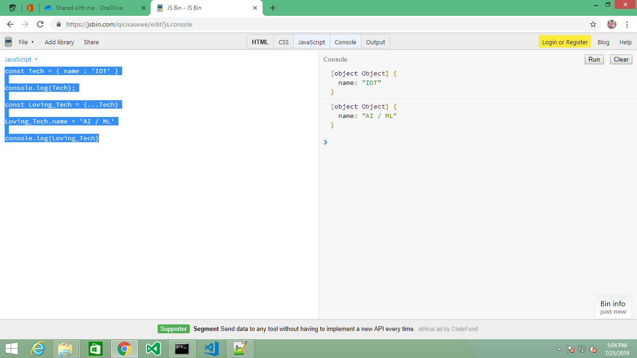

Usage of map function

const number = [1,2,3,4]

console.log(number);

const squared = number.map((num) => {

return num*num;

}

);

console.log(squared);

